Goal: I want to create a game where players gain point by collecting diamonds and there player with the most diamond wins.

To do this, I need to:

* initialize the game
  + import pygame,pygame.init()
  + create a surface for the game
* make the character and background appear
  + upload the image, save it to a variable and use blit()
* make the character move
  + use keyboard to determine which way to move, update character coordinate and redraw the character each time
  + check if character is allowed to move a particular way or not when reach the wall
  + if player move outside
* make sound appear
  + use wav for coin and mp3 for background. Use pygame.mixer.music
* collect diamonds and add to points
  + check if character touches diamond, if yes, move diamond to some where else and increase score by one
* show score and update the score
  + use pygame.font and font.render to create a surface and use .blit() to add surface to screen

Error:

1. cannot move character after character hit a wall, the character remain frozen, cannot move up, down, left, or right
2. character cannot move inside the tunnel

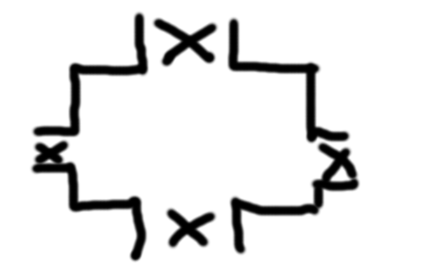

Error Observation:

* When go into the x region, character cannot move left, down, up or right. The character becomes stuck
* I have tried to print to console whenever the character moves into the x region and at that time, canMove is true, however, no print message appear on console
* After the character hit the wall, it moves into region where canMove is false, so the function returns 0 change to the character’s coordinate. But no matter what key I press, no change to the character’s position.

Possible steps to take:

* Look at move down function to see if area defined as can move is correct
* Use mouse click to check if the coordinate for four boundaries is correct

Where the error is:

* The character’s coordinate was measured at the character’s upper left. I was wrong because I defined the character’s position at the character’s center.